STATEMENT OF PURPOSE
Principles:

Outcome- focused

Person-centred

Strengths -based

Psychologically -informed

Coproduction

UASC specialist

www.pathwaystoindependence.org.uk

Our vision is of a world in which all young people are able to fulfil their potential and make the positive transition to independent, adult life.

Our mission is to provide housing, support and training for young people who have experienced disadvantage and isolation.

Our ambition is to develop a replicable model of best practice for agencies and individuals involved in the support of care experienced young people, including those seeking asylum.

We value diversity, encourage individuality, and celebrate difference. We empower each other, respect everyone and treat people with dignity. We believe that all young people should have equality of opportunity, whoever they are and whatever their background.

“I respect Pathways because if I need help they always support me and look out for what is best for me” young person

About us

We are a social purpose business with not-for-profit activities that has seen a two-decade record of successfully supporting thousands of young people across the South East of England. We provide high quality supported accommodation, specialist UASC support and bespoke life skills training to our service users, aged sixteen and over. We use our expertise to help people navigate the difficult path to independence, the complicated asylum process, life in the UK and help them integrate into their local communities. We use our expertise in safeguarding to ensure that concerns are followed up, compromising behaviours are disrupted and risk-taking behaviours are managed and reduced.

Contact us

If you have any questions or would like further information about our services get in touch.

Croydon Voluntary Action
82 London Road
Croydon
London
CR0 2TB

info@ptiuk.org.uk

Young People’s Centre
69 Ship Street
Brighton
East Sussex
BN1 1AE

01273 776166

Our aims – We have worked with our young people to co-produce our aims.
Empower young people to make positive choices by:
- Providing safe, secure housing in areas where their needs can be met and by providing accessible and psychologically informed specialist support.
- By providing information, guidance and support around their rights and responsibilities, realistic options and working towards securing positive outcomes.
Enable young people’s involvement in their communities by:
- Embedding their involvement in decisions that affect them within the organisation and working towards replicating this in the communities in which they live.
- Working in partnership with other agencies to build links with community groups so that they feel connected to others and develop a sense of belonging.

Collaborate to positively influence policy and practice by:
- Challenging stereotypes, raising awareness of the UASC experience and encouraging communities and society to be more welcoming through changes in practice.
- Disseminating good practice guidance on working with UASCs and Triple Planning, through training to Local Authorities and providers to reflect their unique needs.

Our Services
We can work with:
- Any young people who are in care or care experienced
- Young people from refugee and asylum-seeking backgrounds (UASC)
- UASC new arrivals
- Young parents with dependent children
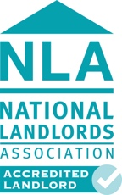
We offer various accommodation options:
- Single units - one bed flats / studios
- Shared units (3, 4 or 5 bed)
- Single-gender accommodation

We offer various support models:
- Enhanced support – 8 hours of support (5 one-to-one and 2 group work)
- Medium support – 5 hours support (3 hours one-to-one and 2 hours group)
- Low support – 4 hours of support (2 hours one-to-one and 2 hours group)
- Support only model (any support model with no accommodation attached)

“Here is fantastic I slept last night, have a lovely room. I feel safe here” young person

We help young people with training to prepare for independent living:
- Delivery of bespoke life skills training
- Support for life skills training provided by colleges and other organisations

We offer training to professionals:
- Introduction to working with unaccompanied asylum-seeking minors
- Triple Planning
Our Outcomes

We are outcomes focused so young people leave the service prepared for independent living. We use the Young Persons Star, and the UASC specialist Outcomes Star Planning Star, for support planning, and we deliver a regular Life Skills programme adapted to individual needs. These enable SMART goals within an action plan to guide our work with targets set by the young people to ensure all our work is informed by the wishes of the young person and they can easily track their own progress.

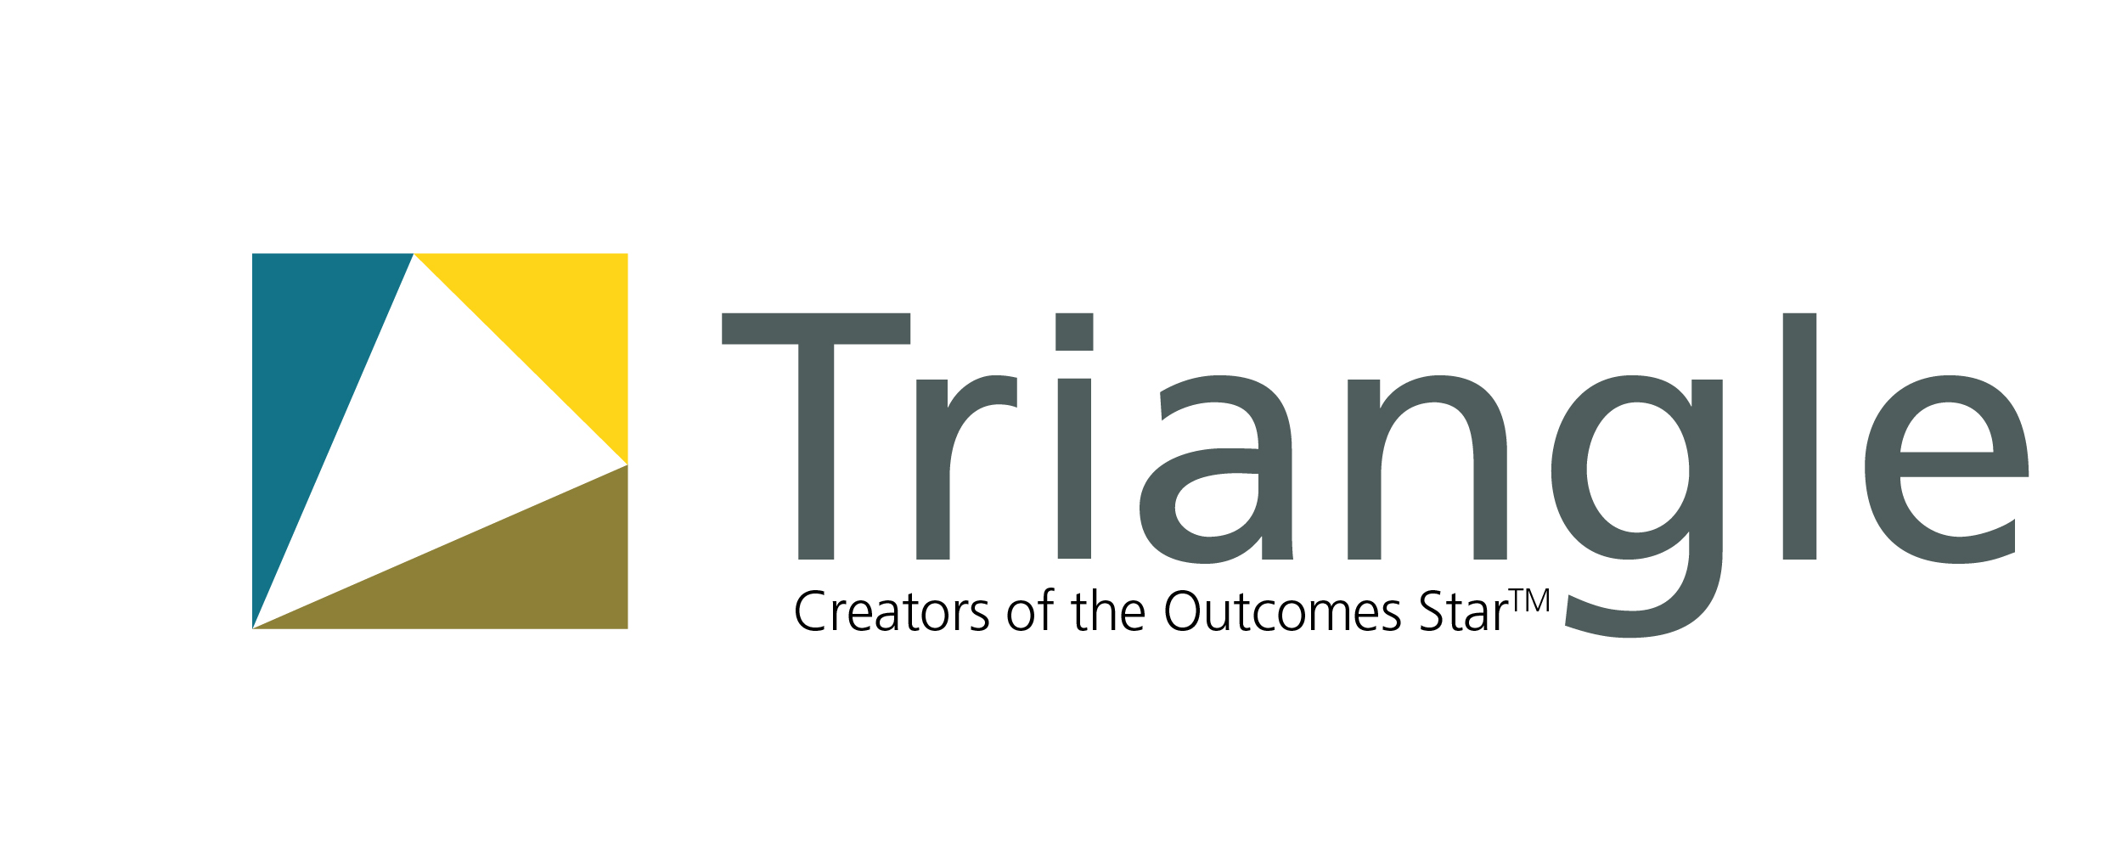

“My real journey started with Pathways… when I felt I could really be the person I wanted to.. Pathways helped me see the bright light, the pathway clearly. I felt like I was going from zero to something, from dark to light and from emptiness to fulfilment.”

Resilience building – We know that young people can draw upon strengths or protective factors like positive educational experiences and a secure support network to overcome their difficulties, achieve great things and thrive in the face of adversity.

Relationship building - We believe that trusting relationships are the springboard for positive decision-making and improve a young persons’ life trajectory, we aim to build positive trusting relationships and connect them to other adults in their communities.

Boundary building – We are trauma informed about young peoples’ lives however we do not make allowances for repeated poor choices; we are clear about our expectations, we make psychologically informed behaviour change interventions, and we have a clear warnings procedure, so that they can lead happier, healthier, more aspirational lives.
UASC specialism – We are the experts when it comes to working with UASC. So when local authorities need an organisation who will provide their young people with holistic support, to ensure they are well-informed, well-prepared, well-supported, they come to us.

“…you couldn’t ask for a better team, dedicated, well trained; they know the process inside out, it’s so vital as we are not experts, they led on everything…” professional
We are experienced at supporting young people through the asylum process, with new arrivals, those who are appeal rights exhausted, at risk of detention, have reporting restrictions or are detained. We work with young people who are preparing to return and in need of reintegration support.
“ Helpful friendly … They come with me, help talk to doctors when no interpreter ” young person
Our support is:
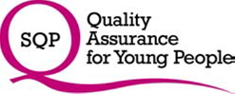
- Outcome-focused
- Person-centred
- Trauma informed
- Strengths-based
- Safeguarding oriented
- Triple Planning based
Service includes:
      - Accommodation costs (based on Local Housing Allowance for under 35s)
      - Support costs (key work, group work and other self-development activities)
      - Support planning using the ‘Young Persons Star’ and the ‘Planning Star’
      - Enrolment in our three-phase bespoke Life Skills programme
      - Experience disrupting exploitation, radicalisation, trafficking, HBV/FGM
      - Use of volunteers through our Connect Programme
      - Out of hours emergency support – On Call Scheme
      - Start up pack (includes cutlery, bedding, basic furnishing - one-off supply)
- We oversee referral processes, case management and housing management
- Strong links to refugee support and community organisations in South East
- Specialist support navigating the asylum process and triple planning
- We deliver training to local authorities on working with UASC
We take safeguarding extremely seriously and as such we are compliant with Brighton and Hove Children’s Safeguarding Children’s Partnership Section 11 Audit and the ‘Safer Surrey’ approach.

Our partners - We believe that positive partnerships achieve the best outcomes for young people, communities and the wider sector.

Student Social Worker Programme – “The work that Pathways does is an invaluable resource and our successful partnership has been driven by the ethos and ethics of Pathways to improve the lives of young people.” Director of Practice Learning, Sussex University
Global Social Club meets every Monday 5 - 7pm. Our team welcome young people aged 14-25 from around the city and around the world. We’re based at the Young People’s Centre in Brighton, delivered in partnership with the Hummingbird Project, Refugee Council, Impact Initiatives and us.
Global Social Club is an awarding winning youth service and recognised as the UK’s first Youth Club of Sanctuary!

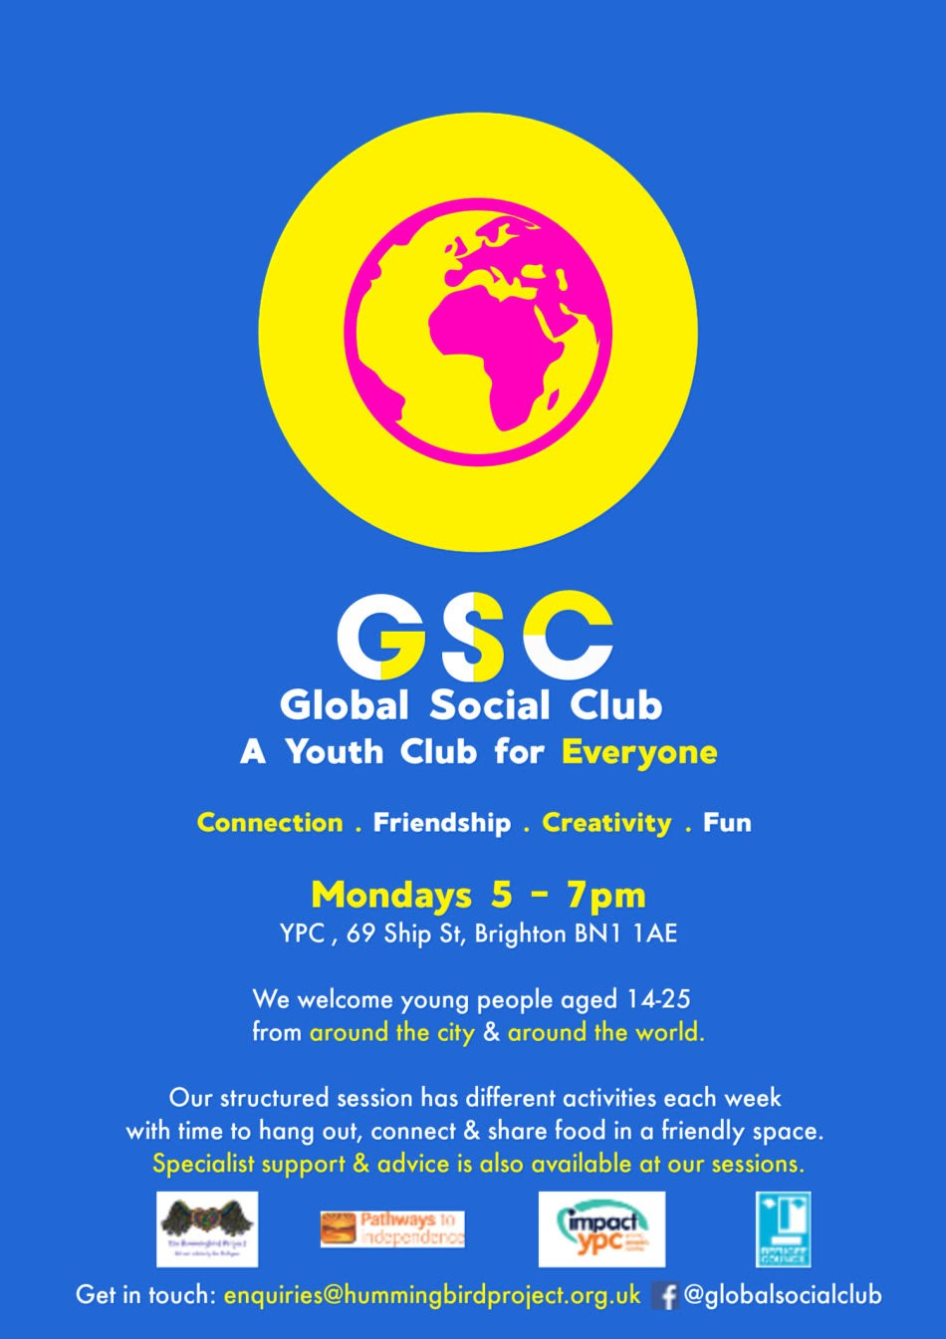

Triangle Consulting, creaters of the Outcomes Star – “Pathways was undoubtedly one of the most impressive and rewarding collaborations, due to the depth of knowledge of their workers and the positive relationships they had with the young people… They are real experts in the field, which is exactly what we need to recreate a Star that speaks to and reflects the reality of people in a sector” Director, Triangle - creators of the Outcomes StarTM

Croydon Voluntary Action – “In a world of busyness, it’s nice to know that I am working with lovely, warm kind external colleagues” CVA colleague

South East Strategic Partnership for Migration – “has greatly valued working with Pathways over a number of years both in their capacity to deliver a vital a specialist input to our regional ‘Outcomes Star’ programme and in evaluating an element of our work with Unaccompanied Asylum Seeking Children. We have enjoyed a collaborative relationship to develop practical resources for Children’s Services both at the front line and strategic planning level”

Hillsong – "It has been a privilege to support the incredible team and young people of Pathways to Independence over the last 4 years! We want to make sure that young refugees and asylum seekers feel welcomed and supported and coming alongside Pathways to Independence have allowed us to practically reach out and play a little part in making a difference." Refugee Response Leader, Hillsong

